**Southern Baptists of Texas Convention**

***Convención de los Bautistas del Sur de Texas***

**New Church Plant Information Update**

***Actualización de Information de la Iglesia Nueva***

**Name of New Church /*Nombre de la Iglesia Nueva***

Click here to enter text.

**Ethnicity Focus/ *Enfoque Étnico***

Click here to enter text.

**Mailing Address/*Dirección Postal***

Click here to enter text.

**City/*Ciudad***

Click here to enter text.

**Zip/*Código Postal***

Click here to enter text.

**Physical Location of Church Plant/*Dirección donde se reunen*** Click here to enter text.

**Church Phone/*Tel casa***

Click here to enter text.

**Website*/Sitio web*** Click here to enter text.

**Planter’s Name/*Nombre del Iniciador***

Click here to enter text.

**Spouse’s Name/*Nombre de la Esposa***

Click here to enter text.

**Cell Phone/*Cel*** Click here to enter text.

**Home Address/*Domicilo***

Click here to enter text.

**Email/*Correo electrónico*** Click here to enter text.

**Name of Sponsor Church */Nombre iglesia patrocinadora*** Click here to enter text.

**Mailing address/*Dirección Postal*** Click here to enter text.

**Pastor’s name/*Nombre del pastor*** Click here to enter text.

**Contact Person/*Persona de contacto*** Click here to enter text.

**Contact email/*Correo electrónico*** Click here to enter text.

**Church phone/*Teléfono para la iglesia*** Click here to enter text.

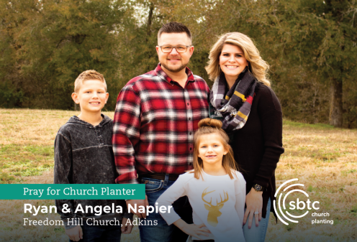Church Planter Prayer Cards

The SBTC will provide you 225 prayer cards.Send a family photo to Alicia Violante at [aviolante@sbtexas.com](mailto:aviolante@sbtexas.com)

Photos must be:

* High resolution (1MB or higher)
* Regular sizing (5x7)
* No blurs, pixilation, appropriate background
* Vertical or horizontal orientation



*Address on prayer card*:

Church plant mailing address

Church plant physical address

*Mail my completed card to*:

Church mailing address

Home address

Please include your Wife’s name and the name of your children (if you wish your children’s names to be on the card.)